3 Steps to expand A16 into the United States wine market
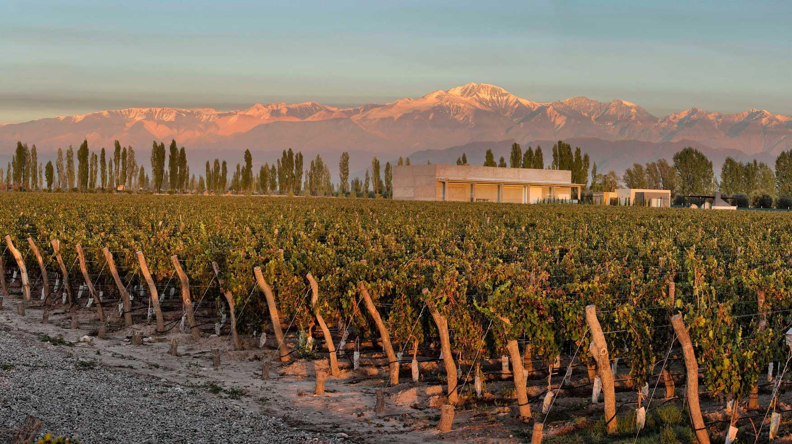
The University of Virginia

January 2019

Prepared for: A16 Management, Jonathan Tari, Natalia Umbrazun

Prepared by: John Grencer, Sarah Nelson, Reagan Redman, Hannah Semmes, & Jacob Ziller

Advised by: Professor Reid Bailey, Professor Stefano Grazioli

Bodega A16 aims to operate at full capacity by increasing United States sales

Expanding A16’s sales network into key U.S. regions will help meet the winery’s goal of increasing operational capacity from 50% to 100%. According to strategic performance improvement and management consulting group, L.E.K. Consulting, U.S. wine consumption is expected to grow to $43 billion USD by 2022, a growth rate of 6% per year (Exhibit 1). As Argentine consumer preferences shift away from wine and towards beer, (Frederick, 2018) A16 should strategically expand its U.S. presence to diversify its market beyond South America and to enter a new market that is increasing its wine consumption.

Williamsburg Winery is not the growth avenue for A16’s ambitious goals

The United States’ wine and spirits industry operates through a 3-tier system. By regulation, A16 is required to partner with U.S. importers, distributors, and retailers. Currently, A16’s only U.S. partner is Williamsburg Winery (WW). While this relationship is mutually beneficial, Williamsburg does not intend to expand the partnership beyond its current scope. Therefore, A16 must find new growth opportunities. With over 1,100 wine distributors in the U.S. (Douglas, 2017), A16 has a wide selection of potential partners. Each distributor has a different focus: some focus on large-scale operations across the nation while others focus on boutique wines in key locations. A16 must identify distributors that can reach its intended demographic of consumers who favor international, boutique wines. To reach these final consumers, A16 should strategically leverage different distribution channels to increase brand recognition and sales over time.

A16 can expand its U.S. presence through a three-step process involving three different distribution channels: Wine Clubs, E-Commerce, and Traditional Stores

A16 seeks to increase its U.S. sales, however it does not have the necessary brand recognition to differentiate itself on the market. The winery must expand its focus beyond the logistics of wine importing and focus on how to ensure its brand gains traction with Usonians. Within the 3-tier system, Wine Clubs (Exhibit 2), E-Commerce (Exhibit 3), and Traditional Stores (Exhibit 4) all have different processes for how wines ultimately reach the final consumer. A16 should first focus on gaining a brand recognition and a customer following within the niche market of wine clubs, then expand product availability to E-Commerce platforms, and end its 3-step expansion plan with placing products on traditional store shelves.

Step 1: Increase brand recognition and product exposure through Wine Clubs

Wine Clubs (Exhibit 5) are a popular distribution channel in the United States as they expose consumers to many different types and brands of wine. As A16 is a smaller, boutique winery with a limited marketing budget, we recommend that it adopt a comparable strategy to similarly-sized wineries. In the United States, between 70-95% of E-Commerce wine transactions made through small wineries’ websites are done by the wine club members (Blacksquare). Club members are first exposed to new wines in their monthly packages. After sampling different brands, members can then purchase their favorite products from the wineries’ websites. Without membership in these wine clubs, it is difficult to gain traction in the U.S. E-Commerce market. The Wine Clubs distribution channel is a strategic first step because it would introduce A16’s wines to frequent and diverse wine consumers who are interested in new, foreign wines. Along with high growth potential (SevenFiftyDaily) and a targeted market, wine clubs would spread A16’s brand recognition through “word of mouth.” Wine clubs are small, connected communities. Members frequently discuss wine brands with one another.

Step 2: Make wines accessible through E-Commerce platforms

Once consumers know the A16 brand through Wine Clubs, they can easily find the winery’s website online through internet searches. Trends indicate that E-Commerce is a logical platform to enter, as it is growing across industries (Exhibit 6). Whether through wine-specific websites, such as Wine.com, or massive online retailers, such as Amazon.com, U.S. consumers are increasingly shifting towards online purchases.

When entering the E-Commerce platform, it is important to strategically understand customer segments. Age is a particularly important demographic: Millennials make 54% of their purchases online, as opposed to in-store retailers (Hatch, 2018). By focusing efforts on this younger demographic, A16 would capture more of this market in the future as online purchases continue to grow (Exhibit 7).

Step 3: Enter the Traditional Stores’ market as a recognized industry player

Putting wines on traditional store shelves is a common first step into the US wine market. However, wine brands often lack differentiation in traditional stores. Simply placing a product on in-store shelves will not be enough to drive the sales of a small, lesser-known brand. Entering this traditional channel after positioning A16 in wine clubs and online platforms is a more strategic decision. A 2015 Millennial Consumer Study found that 62% of Millennials are more likely to become loyal customers to brands that they first engage with online (Wine Direct, 2015). Even though traditional retailers, like supermarkets and liquor shops, comprise 72.5% of the $32 Billion US wine market, (Grand View Research, in 2017), traditional stores is the slowest growing segment of the alcohol market, with 0.2% annual growth (IBIS World, 2018).
A16 should target locations with the least regulations and greatest populations

When importing, distributing, and selling wine in the U.S., it is best to think of every state as its own, individual country with its own, separate regulations. Given the logistical complexity of states with high regulations and large taxes, it is best for smaller wineries to focus on regions with less regulations, but overall large populations and high-density cities (IBISWorld, 2018). Based on these criteria we suggest that A16 target the key states of California, Nevada, New York, New Jersey, Virginia, and Florida (Exhibit 8).

A16 should immediately begin the recommended 3-step process to increase brand recognition and sales in the U.S.

Wine clubs expose a large range of customers to different wine brands in the convenience of their own homes. Once consumers are exposed to the A16 brand, the winery should progress to E-Commerce platforms, a fast-growing market segment. Finally, after A16 establishes its brand online, the winery will be better equipped to compete and succeed in the larger market of traditional stores.

To initiate this recommended phased strategy, 17 leads (Exhibit #9) have been contacted. These leads are a mix of wine clubs, wine competitions for A16 to enter its wines into, E-Commerce platforms and stores, retail stores, importers, and distributors. As initial contact has been made with all these vendors, the companies are familiar with A16’s name and a brief overview of its intention to enter the US market. We recommend that A16 continue conversations with these groups to better understand the potential partnerships, their established distribution channels, and pricing. It is important that the winery immediately follow-up with these groups while the interactions are still fresh and individuals are more motivated to act.

Exhibit 1: U.S. wine consumption is steadily growing every year

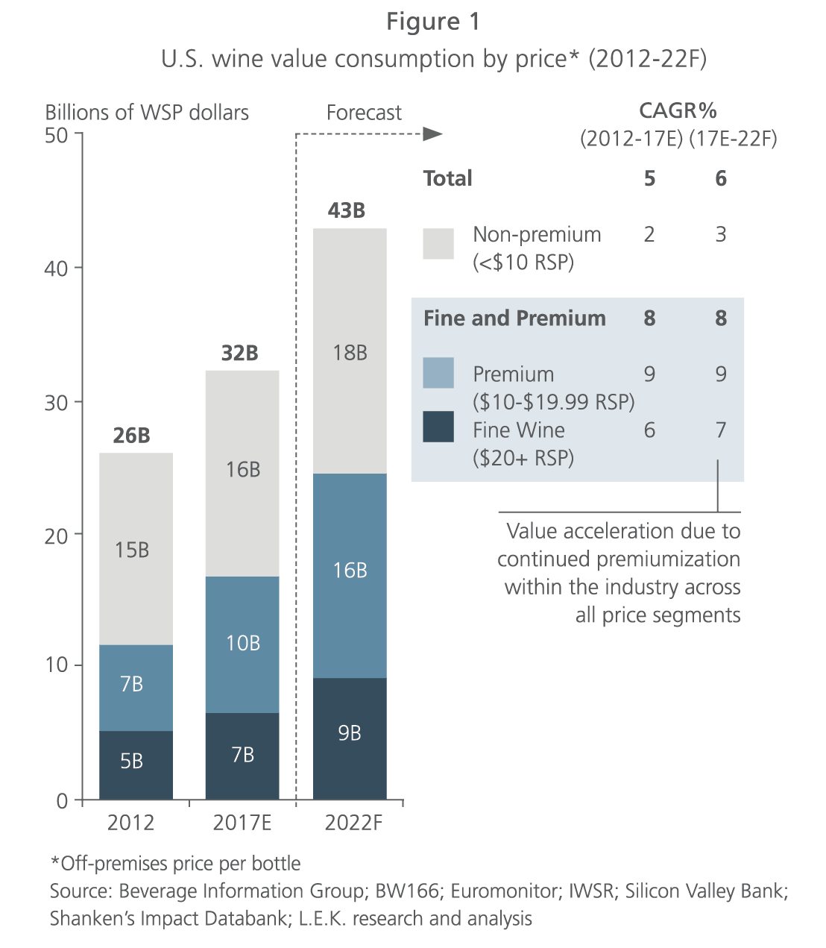

Overall, wine consumption has grown from $26 billion USD in 2012 to $32 billion USD in 2017. Experts project that the market will reach a total of $43 billion USD in 2022.

Exhibit 2: Wine Clubs involve 6 steps from winery to final consumer

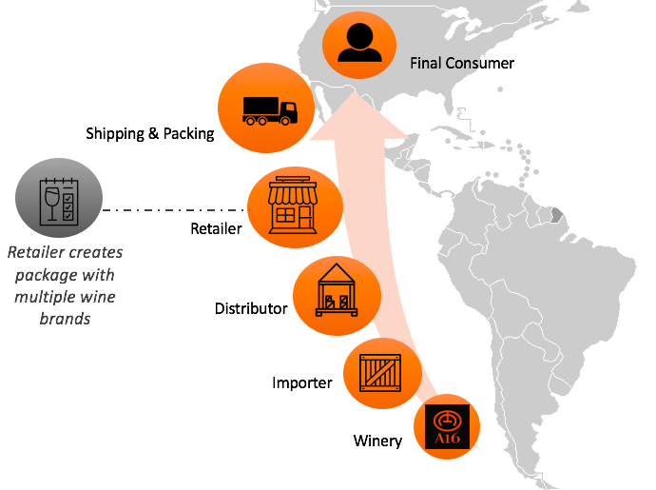
This diagram emphasizes how the Wine Club distribution process differs from the other distribution processes. The main difference with Wine Clubs is how the wine reaches the final consumer: the retailer (the wine club) packages multiple wine brands for that shipment. These packages are then shipped to the final consumer.

Exhibit 3: E-Commerce involves 7 steps from winery to final consumer

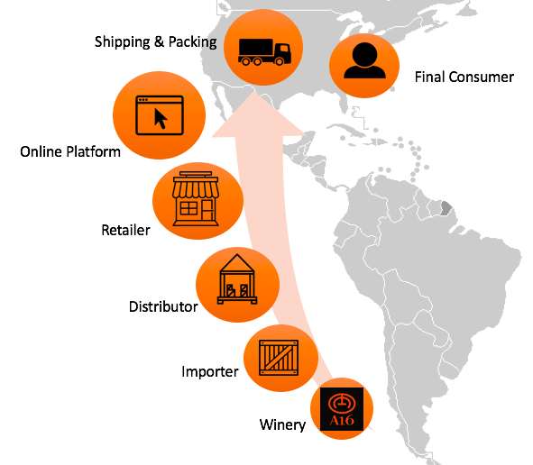
This diagram emphasizes how the E-Commerce wine distribution process differs from the other distribution processes. The key difference with E-Commerce is that instead of consumers traveling out to a retailer’s physical store to purchase bottles, consumers purchase their wine online through a computer. The wine is then shipped directly to them.

Exhibit 4: Traditional Stores involve 5 steps from winery to final consumer

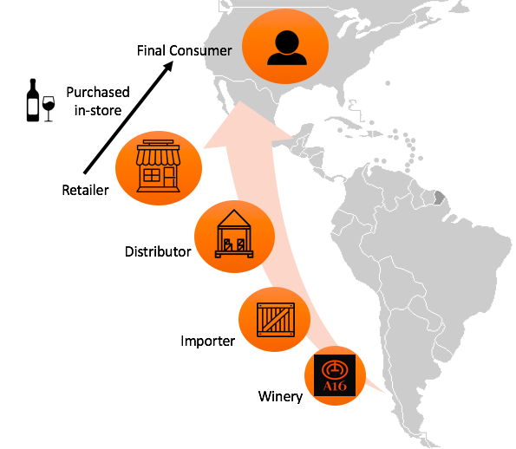

This diagram represents the traditional 3-tier system for retail stores. The wine travels from a winery, to an importer, to a distributor, and finally to the retailer. Consumers then purchase bottles from the retailer’s physical store shelves.

Exhibit 5: Wine Clubs introduce consumers to a wide variety of wines
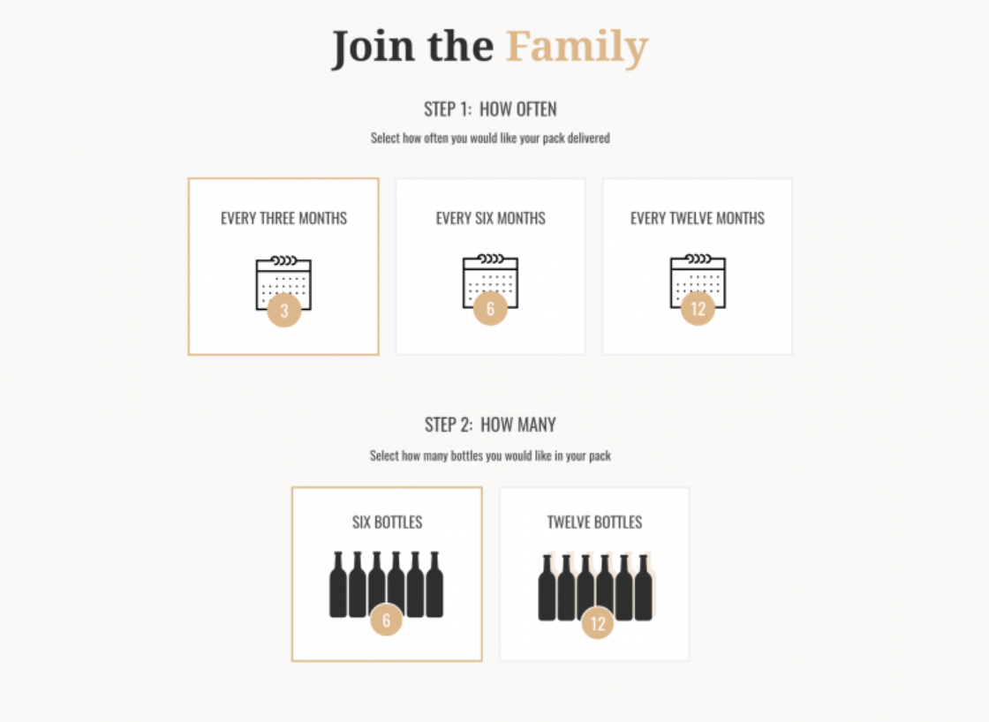
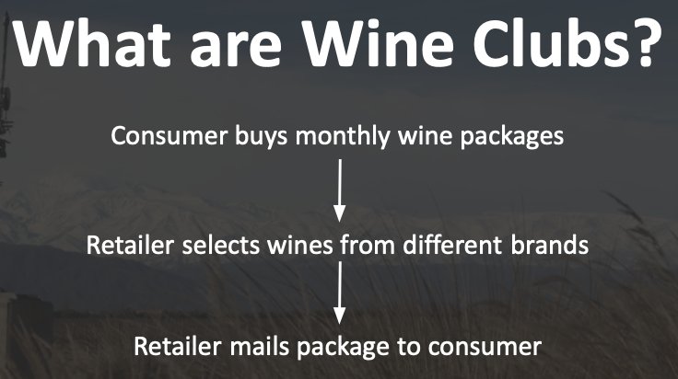
This visual is an example user-interface of what a final consumer might encounter when joining a wine club.
SOURCE: https://cru.io/user-choice-wine-clubs-how-they-work-and-what-are-the-benefits/
Exhibit 6: E-Commerce is especially popular with the Millennial generation

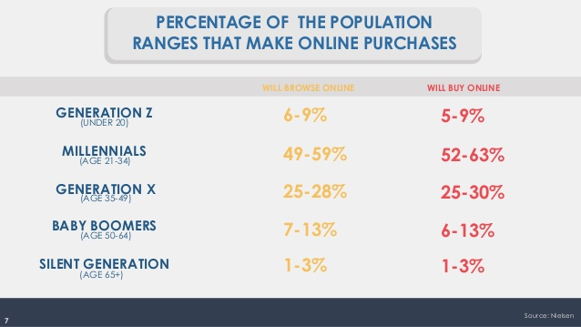

Exhibit 7: E-Commerce is a growing across all industries, including wine

- In 2016, U.S. online wine sales increased by 18.5%, representing 4% of the nation’s wine sales overall. (Baynes, 2016).

- Since 2012, the total amount of direct-to-consumer (DtC) E-Commerce wine consumption has doubled every year. In 2017, 10% of sales came from E-Commerce platforms (L.E.K Consulting, 2018).

- As younger, busy consumers who prefer the ease and convenience of online shopping reach the U.S. alcohol consumption age (21 years old), online channels for sales are expected to grow. Millennials increased their consumption of wine by about 8% from 2012-2016. By 2026, millennials are predicted to hold the largest segment of U.S. wine consumption (Wilson, 2018).

Exhibit 8: A16 should target high population states with low regulations

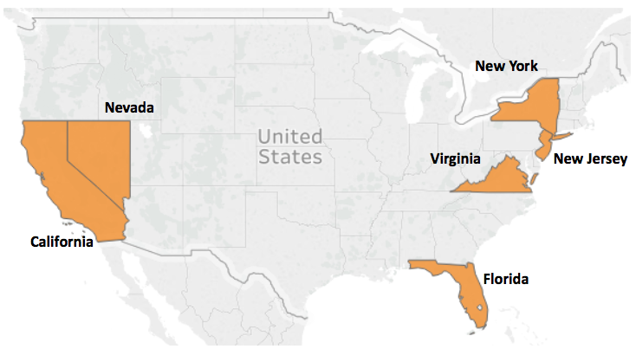

Source: IBISWorld

These 6 states have highly populated cities, lenient regulations, and a large of boutique wine following. Specifically, New York was recommended an industry importing expert as a state which provided the best starting opportunities for smaller wineries such as A16.
Exhibit 9: Initial contact has been made with vendors across the US distribution tiers

Wine Clubs
Company Name:  Point of Contact:  Email / Phone Number:  Website:  What they do: | Wine of the Month Club  Cellarmaster & President, Paul  paul@womclub.com  https://www.wineofthemonthclub.com/  Wine Club & E-Commerce. Online wine club that specializes in authentic wines around the world, including Argentina. It is the oldest mail order wine club in the United States!
Company Name:  Point of Contact:  Email / Phone Number:  Website:  What they do: | HelloFresh  *A16 will be contacted for more information*  customerservice.us@hellofresh.mypurecloud.com  www.hellofresh.com/tasty/wine/  Wine Club. HelloFresh wine club that is a part of a larger meal ordering company. The wine club is popular all over the world and even pairs wines with some of the meals!
Company Name:  Point of Contact:  Email / Phone Number:  Website:  What they do: | Plonk Wine Club  Etty Klein  etty@plonkwinemerchants.com / 1-310-867-5817  Plonkwinemerchants.com  Wine Club. American wine club specializing in international, organic, family-owned wineries. Has been ranked highly by well-known American literature such as The Huffington Post, Forbes, Food Republic, and more.
Company Name:  Point of Contact:  Email / Phone Number:  Website:  What they do: | Gold Medal Wine Club  Owner, David Chesterfield  info@goldmedalwine.com  www.goldmedalwineclub.com/  Gold Medal Wine Club is a a club featuring small, authentic wineries from around the world. Wineries that make it into this club must meet strict qualifications to be selected, including awards and recognition.

Wine Competitions
Company Name:  Website:  Competition:  What they do:  Timeline:  Entry Cost: | Decanter  decanter.com/awards-home/dwwa-es/fechas-clave-y-precios-dwwa-278713/  Decanter Worldwide Wine Awards  “Judging is organised into categories, based on region...The judges taste wines individually. They know the region, style and price bracket, but they don’t know... the brand name. They compare notes and reach a consensus on each wine’s medal. Medal categories correspond to the 100-point scoring system used by Decanter and many top wine critics around the world.”  Entry Deadline: 1 March 2019  $250 USD per entry
Company Name:  Website:  Competition:  What they do:  Timeline:  Entry Cost: | The International Wine & Spirit Competition Ltd (IWSC)  https://www.iwsc.net/how-to-enter  Southern Hemisphere (Wine)  “Entries are received from 90 countries worldwide and each sample is judged according to its class... the competition does not only recognize excellence in wines and spirits, but also individuals, with awards such as Winemaker of the Year, Wine Communicator of the Year ad Wine Buying Team of the year.”  Entry Deadline: 17 July 2019  150 Euros per entry
Company Name:  Website:  Competition:  What they do:  Timeline:  Entry Cost: | TexasMonthly International Wine Awards  https://competition.texsomiwa.com/wines/results  International Wine Awards  “The TEXSOM International Wine Awards judging is conducted by panels of four qualified tasters...Each panel includes a trained Panel Director from the TEXSOM International Wine Awards team to facilitate the judging flow and record-keeping...Each judging panel is assembled with a mix of disciplines including judges with specialist skills and those with a global perspective so that multiple viewpoints will be considered in the evaluation of the wines.”  Entry Deadline: 31 January 2019  $105 USD per entry

E-Commerce
Company Name:  Point of Contact:  Email / Phone Number:  Website:  What they do: | LibDib  Business Development, Joe Cirone  joe.cirone@libdib.com / 1-408-769-2404  Libdib.com  Distributor & E-Commerce. Operates an online store where small craft beverage makers, such as A16, are able to sell to restaurants, bars, and retailers. Joining is free. Payment is made upon delivery of sales.
Company Name:  Point of Contact:  Email / Phone Number:  Website:  What they do: | BlackSquare  Director of Client Services & Technology, Jenn Aguilar  jenn.aguilar@blacksquare.io / 1-403-668-4715  https://www.blacksquare.io/wine/  E-Commerce Consultant. Global direct-to-consumer (DtC) wine solutions focusing on E-Commerce, wine subscriptions, reporting, and inventory management. Not a distributor or importer, but helpful for A16 once selling in the US market.
Company Name:  Point of Contact:  Email / Phone Number:  Website:  What they do: | Grand Cata Latino Wine Co.  They will be in contact with you.  info@grandcata.com / 1-202-525-5702  http://www.grandcata.com/contact-us/  Wine Club & Traditional Store. Nationally recognized retailer located in Washington D.C. The company is dedicated to bringing craft South American wines to the U.S. They host wine tastings and send monthly wine shipments to subscribers.

Traditional Retail
Company Name:  Point of Contact:  Email / Phone Number:  Website:  What they do: | Total Wine & More  Julee Sawyer  WineNewItems@totalwine.com / 1-855-328-9463  https://www.totalwine.com/  E-Commerce & Traditional Retail. The largest independent retailer of fine wine in the U.S., operating 193 stores across 23 states. Warehouses and ships to consumers in 23 different states.
Company Name:  Point of Contact:  Email / Phone Number:  Website:  What they do: | Grand Cata Latino Wine Co.  They will be in contact with you.  info@grandcata.com / 1-202-525-5702  http://www.grandcata.com/contact-us  Traditional Store & Wine Club. Nationally recognized retailer located in Washington D.C. The company is dedicated to bringing craft South American wines to the U.S. They host wine tastings and send monthly wine shipments to subscribers.

Importers & Distributors
Company Name:  Point of Contact:  Email / Phone Number:  Website:  What they do: | American Spirits Exchange  Partner, Philip Kolodziey &  Philip@americanspiritsltd.com  Americanspiritsltd.com  Importer & Distributor. Provides services such as warehousing on the East and West Coasts of the U.S. They also providing permitting, PO processing, invoicing, and compliance for wineries based on single per-case fees.
Company Name:  Point of Contact  Email / Phone Number:  Website:  What they do: | MHW, Ltd.  Marketing Coordinator, Michelle Street  mstreet@mhwltd.com / 1-516-869-9170 ext. 234  Mhwltd.com  Importer & Distributor. Coordinate logistics of the import and distribution process for new craft wine, spirit, and beer brands in the U.S.
Company Name:  Point of Contact:  Email / Phone Number:  Website:  What they do: | Southern Glazer’s  SVP Supplier Management, Louis Zweig  Lzweig@sgws.com / 972-392-8389  www.southernglazers.com  Importer & Distributor. Wine and spirits distributor active in 44 states. As the largest alcohol distribution company in the country, Southern Glazer’s holds 17.6% of the US sector’s total market sales.

